37dyed beam moving head lamp instruction manual
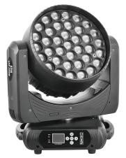
Thank you for using the products produced by our company, in order for you to use this product safely and effectively, please read this instruction manual carefully and completely before you use this product. This manual contains a description of the performance of the product and how to install it safely, as well as important information about use, please keep it properly for reference when using. Please strictly follow the relevant instructions when installing and using.

● Product technical parameters
- Rated voltage: AC100V ~ 240V 50/60Hz
- Input power: 600W
- Light source specifications: 37 15W four in one LED Osram light source
- Approved life: 50,000 hours
- Color: red, green, blue and white multi-color
- Focusing: 4 ° -60 ° DMX linear focus, with automatic focus function
- Color temperature control: built-in CTO DMX linear dimming
- Electronic strobe, 0.3 ~ 25 times / second, can choose synchronous, asynchronous random strobe
- Dimming: electronic dimming 0 ~ 100% linear adjustment, with a gamma curve dimming frequency 1.2K ~ 25K adjustable, with macro command dimming linear stable and smooth without flicker, using a stable constant current driver and power supply, suitable for video shooting
- Rotation angle: XY axis using high-speed silent 60 three-phase motor drive, with high-precision imported Hall positioning device, so that the operation of more accurate positioning, when the misstep can automatically return to the horizontal, vertical speed adjustable; XY axis rotation function and take the reverse function
- Horizontal direction 540 ° (16 bit precision scanning), vertical direction 270 ° (16 bit precision scanning)
- Control mode: 22 (streamlined) / 50 (standard) 2 channel control mode, standard DMX512 protocol, RDM protocol
- Control interface: DMX512 interface (3-core / optional 5-core), power cord hand-held socket
- Hibernation function: the use of advanced technology to achieve remote hibernation function, when the lamps and lanterns disconnect the signal automatically into the hibernation state, so that the lamps and lanterns more stable and safer
- Display function: 1.77 inch LCD display, bilingual menu, sensor fault display, temperature display
- Heat dissipation system: using high conductivity light aluminum heat sink, fan intelligent monitoring technology according to the temperature of the lamps and lanterns automatically adjust the fan rotation, built-in overheating protection intelligent system / intelligent temperature and noise balance module
- Protection grade: IP20, optional rain cover protection grade up to IP44
- Lamp packaging: waterproof and shockproof air box or carton
- Net weight: 13.50KG Gross weight: 15.55KG Product size: 35*29*41CM Package size: 47*34*52M (a load of one)
- Features
- 1. Screen automatic rotation function, the system can automatically rotate the screen according to the direction of gravity, no need to manually rotate! You can also turn off the automatic rotation function
- 2. One motherboard design, solve the problem of smoke oil, colored paper, etc., can be individually segment control control light beads, running horse effect, built-in and other rich effects, the product built-in RDM remote console dial code upgrade function

● Product Considerations
- In order to ensure the service life of the product, this product should not be placed in a wet or leaky place, and can not work in an environment where the temperature exceeds 60 degrees  Do not place this product in places that are easy to loosen or shake.
- In order to avoid the danger of electric shock, the repair request of this product is for professional repair.
- When the bulb is used, the power supply voltage should not change more than ±10%, the voltage is too high, the life of the bulb will be shortened, and the voltage is too low, which will affect the light color of the bulb.
- After the power is cut off, it takes 20 minutes to use the lamp to cool down sufficiently before it can be used again.
In order to ensure the normal use of this product, please read this instruction carefully. Signal Line Connection (DMX)
Use RS-485 cables that meet specifications: shielded, 120ohm characteristic impedance, 22-24 AWG, low capacitive reactance. Do not use microphone cables or cables with different prescribed characteristics. Terminal connections must use 3 or 5-pin XLR type male/female connectors. (Minimum 1/4 W).
Important: The wires must not come into contact with each other or with the metal housing.
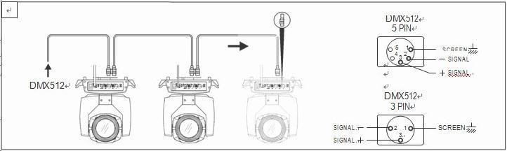
Figureinstallation1 Schematic diagram of DMX signal line connection

● Luminaire
Luminaires can be placed horizontally, hung obliquely and upside down. When hanging obliquely and upside down, be sure to pay attention to the installation method, .
As shown in Figure 2, before positioning the lamp, to ensure the stability of the installation site, when reversing the hanging installation, it must be ensured that the lamp does not fall off the support frame, and it is necessary to use a safety rope through the support frame and the lamp handle for auxiliary hanging to ensure safety and prevent the lamp from falling and sliding.
When the lamp is installed and debugged, pedestrians are prohibited from passing underneath, and the safety rope is regularly checked for wear and whether the hook screw is loose.
If the hanging installation is not stable, resulting in the fall of the lamp and all the consequences, our company does not assume any responsibility.
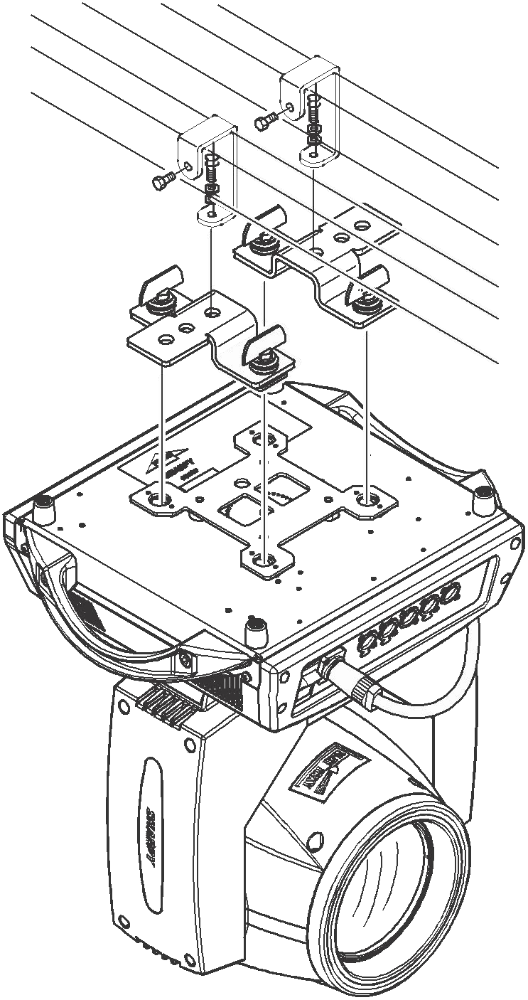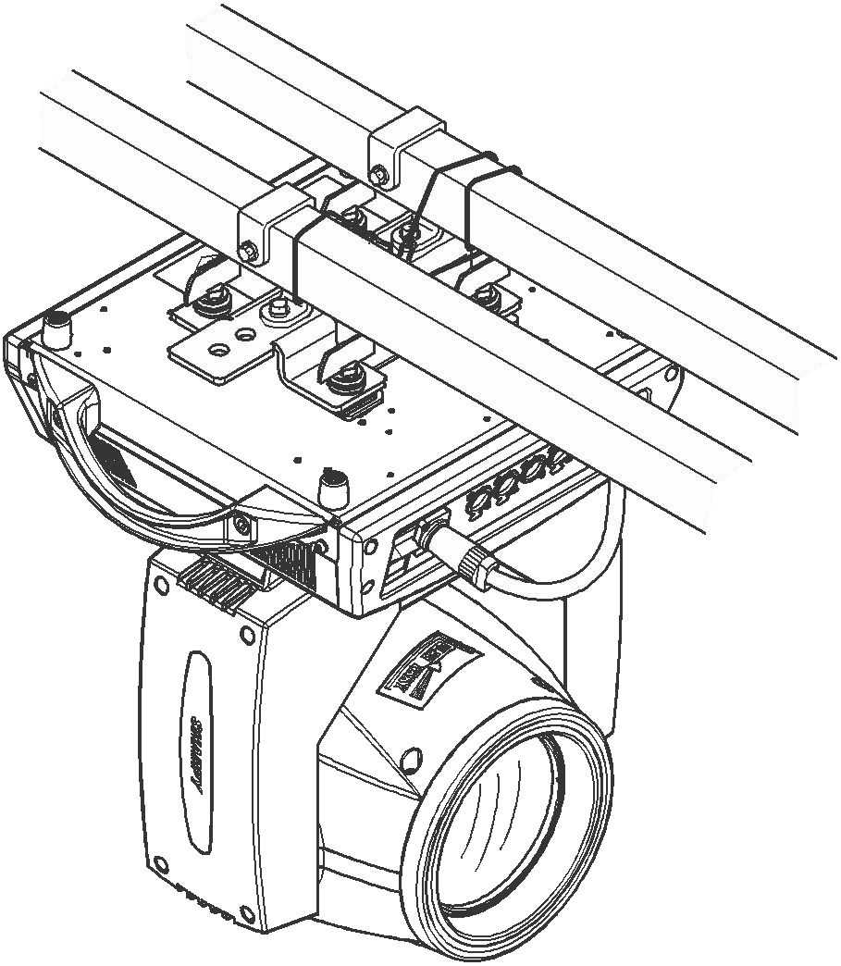
Figure 2 Schematic diagram of upside-down luminaires

● Menu desktop
●
Menu
header
interface
001
temperature
：
**
℃
DMX-512
mode
The
current
operating
operating
The
current
Address
code

Address Settings Manual
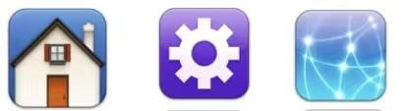
Calibration Reset Information
◆ Address: Click to enter the address code settings
◆ Settings: Tap to enter system settings
◆ Manual: Tap to enter manual mode
◆ Calibration: Tap to enter the password to enter the system calibration mode
◆ Reset: Tap to enter the system reset mode
◆ Information: Click to enter to view system information

● Menu structure
Main menu | Secondary menu | Three levels of menus/parameters
address | 001 - 512 | (Add the number of channels each time, minus normal)
System settings | Operating mode | DMX/voice/self-propelled  1/self-propelled 2
System settings | Channel mode | 22CH/50CH
System settings | Horizontal reversal | On/Off
System settings | Reverse vertically | On/Off
System settings | Hall error correction | On/Off
System settings | Optocoupler error correction | On/Off
System settings | Signal hold | On/Off
System settings | Screen saver | On/Off
System settings | Screen flip | On/Off/Auto
System settings | Synchronize updates | On/Off
System settings | language | Medium/EN
System settings | Factory reset
Manual mode | Manually control channel values | 000-255
System calibration | X-axis motor | 000-255
System calibration | Y-axis motor | 000-255
System calibration | Focus motor | 000-255
System calibration | Rotating motors | 000-255
System calibration | Red-white balance | 000-255
System calibration | Green white balance | 000-255
System calibration | Blue white balance | 000-255
System calibration | White white balance | 000-255
System calibration | power | 000-255
System calibration | MIC sensitivity | 000-255
System calibration | Change Password | Enter a new password
System reset | Effect motor reset | Effect palette reset except XY
 | Scan motor reset | Only the XY axis is reset
 | All motors reset | Lamp reset
System information | Reset the information | Display specific information content
System information | DMX data detection | Displays the specific DMX test content
System information | Sensor information | Displays optocoupler and  Hall-specific information
System information | Hardware version | Displays the hardware version number
System information | Software version | Displays the software version number

◆Screen auto-rotation function
The system automatically rotates the screen according to the direction of gravity, without the need for manual rotation. It is also possible to turn off the auto-rotation function.

◆Manual control
This interface is used to control the current luminaire.
Press the "OK" key to enter the editing state. Press the "Up" and "Down" keys to change the channel value. Press OK again to save the modified value and exit the edit, press Exit to save the modified value without saving the modified value, and exit the edit directly.

◆System calibration
Here, a layer of password is set to prevent non-professionals from misoperation. Press the "OK" key for password verification.
Options | illustrate
Initial position calibration | After entering the sub-interface, the reset position of the X-axis, Y-axis and other motors can be adjusted to make up for the error in the hardware installation, and the adjustment range is  0~255,127 indicates that there is no adjustment.
White balance calibration | Adjustable lamp bead white balance, adjustment range 0 ~ 255, 255 indicates that there is no adjustment.
Power calibration | Adjustable lamp power, adjustment range 0 ~ 255, 255 indicates that there is no adjustment.

◆Reposition
Press the "Up" and "Down" keys to switch the reset mode, press "OK" and reset directly.
Options | illustrate
head | The effect disc is reset except XY
XY | XY axis reset only
all | Luminaire reset

◆System information
Options | illustrate
Reset error message | If the red ERR indicator lights up, it means that the lamp is running incorrectly, and the details can be viewed on the sub-interface.
DMX data monitoring | This takes you to the sub-interface, displaying the channel values as numeric values for viewing.
Sensor information | Real-time monitoring of the status of various photoelectric switches, halls and other sensors on the lamp.
Hardware version number | Luminaire hardware information.
Software version number | Luminaire software version.

◆Channel table 22CH Channel settings
Number of channels | function | Range of values | Channel description
1 | X-axis | 0-255 | 0-540°
2 | X-axis fine-tuning | 0-255 | 16Bit adjustable
3 | Y-axis | 0-255 | 0-270°
4 | Y-axis fine-tuning | 0-255 | 16Bit adjustable
5 | XY speed | 0-255 | XY axis (horizontal, vertical) speed from fast to slow
6 | Focusing | 0-255 | Linear focus
7 | Total dimming | 0-255 | Linear dimming from dark to light
8 | Strobe | 0-3 | Turn on the light
8 | Strobe | 4-63 | Synchronous strobe_ speed from slow to fast
8 | Strobe | 64-66 | Turn on the light
8 | Strobe | 67-126 | Pulse strobe_ speed from slow to fast
8 | Strobe | 127-129 | Turn on the light
8 | Strobe | 130-189 | Flash_ speed from slow to fast
8 | Strobe | 190-192 | Turn on the light
8 | Strobe | 193-252 | Random strobe
8 | Strobe | 253-255 | Turn on the light
9 | Red dimming | 0-255 | Red dimming from dark to light
10 | Green dimming | 0-255 | Green dimming from dark to light
11 | Blue dimming | 0-255 | Blue dimming from dark to light
12 | White dimming | 0-255 | White dimming from dark to light
13 | Temperature | 0 | Not functional
 |  | 1-255 | From 8000K to 2500K
14 | Color macros | 0 | Not functional
14 | Color macros | 0-247 | Preset colors
14 | Color macros | 248-255 | Rainbow effect
15 | Graphic effects | 0-9 | Not functional
15 | Graphic effects | 10-19 | Graphic effect 1
15 | Graphic effects | 20-29 | Graphic effects 2
15 | Graphic effects | 30-39 | Graphic effect 3
15 | Graphic effects | … | ...
15 | Graphic effects | 240-249 | Graphic effects 24
15 | Graphic effects | 250-255 | Graphic effects 25
16 | Dynamic effects | 0-9 | Not functional
16 | Dynamic effects | 10-19 | Dynamic effect 1 (with color channel)
16 | Dynamic effects | 20-29 | Dynamic effect 2 (with color channel)
16 | Dynamic effects | … | ...
16 | Dynamic effects | 120-129 | Dynamic Effects12 (with color channels)
16 | Dynamic effects | 130-139 | Dynamic effects13
16 | Dynamic effects | 140-149 | Dynamic effects14
16 | Dynamic effects | … | …
16 | Dynamic effects | 240-249 | Dynamic effects24
16 | Dynamic effects | 250-255 | Dynamic effects25
17 | Effect speed | 0-64 | The effect frame index
17 | Effect speed | 65-159 | The effect is changing from fast to slow
17 | Effect speed | 160-255 | The effect is reversed from slow to fast
18 | Backlit red | 0-255 | Control (15, 16) channel backlight red
19 | Backlit green | 0-255 | Control (15, 16) channel backlight green
20 | Backlit blue | 0-255 | Control (15, 16) channel backlight blue
21 | Backlit white | 0-255 | Control (15, 16) channel backlit white
22 | reposition | 0-239 | Not functional
22 | reposition | 240-250 | All reset 5s is valid
22 | reposition | 251-255 | Not functional

50CH Channel settings
Number of channels | function | Range of values | Channel description
1 | X-axis | 0-255 | 0-540°
2 | X-axis fine-tuning | 0-255 | 16Bit adjustable
3 | Y-axis | 0-255 | 0-270°
4 | Y-axis fine-tuning | 0-255 | 16Bit adjustable
5 | XY speed | 0-255 | XY axis (horizontal, vertical) speed from fast to slow

6 | Focusing | 0-255 | Linear focus
7 | Total dimming | 0-255 | Linear dimming from dark to light
8 | Strobe | 0-3 | Turn on the light
8 | Strobe | 4-63 | Synchronous strobe_ speed from slow to fast
8 | Strobe | 64-66 | Turn on the light
8 | Strobe | 67-126 | Pulse strobe_ speed from slow to fast
8 | Strobe | 127-129 | Turn on the light
8 | Strobe | 130-189 | Flash_ speed from slow to fast
8 | Strobe | 190-192 | Turn on the light
8 | Strobe | 193-252 | Random strobe
8 | Strobe | 253-255 | Turn on the light
9 | Red dimming | 0-255 | Red dimming from dark to light
10 | Green dimming | 0-255 | Green dimming from dark to light
11 | Blue dimming | 0-255 | Blue dimming from dark to light
12 | White dimming | 0-255 | White dimming from dark to light
13 | Temperature | 0 | Not functional
13 | Temperature | 1-255 | From 8000K to 2500K
14 | Color macros | 0 | Not functional
14 | Color macros | 0-247 | Preset colors
14 | Color macros | 248-255 | Rainbow effect
15 | Graphic effects | 0-9 | Not functional
15 | Graphic effects | 10-19 | Graphic effect 1
15 | Graphic effects | 20-29 | Graphic effects 2
15 | Graphic effects | 30-39 | Graphic effect 3
15 | Graphic effects | … | ...
15 | Graphic effects | 240-249 | Graphic effects 24
15 | Graphic effects | 250-255 | Graphic effects 25
16 | Dynamic effects | 0-9 | Not functional
16 | Dynamic effects | 10-19 | Dynamic effect 1 (with color channel)
16 | Dynamic effects | 20-29 | Dynamic effect 2 (with color channel)
16 | Dynamic effects | … | ...
16 | Dynamic effects | 120-129 | Dynamic Effects12 (with color channels)
16 | Dynamic effects | 130-139 | Dynamic effects13
16 | Dynamic effects | 140-149 | Dynamic effects14
16 | Dynamic effects | … | ...
16 | Dynamic effects | 240-249 | Dynamic effects24
16 | Dynamic effects | 250-255 | Dynamic effects25
17 | Effect speed | 0-64 | The effect frame index
17 | Effect speed | 65-159 | The effect is changing from fast to slow
17 | Effect speed | 160-255 | The effect is reversed from slow to fast
18 | Backlit red | 0-255 | Control (15, 16) channel backlight red
19 | Backlit green | 0-255 | Control (15, 16) channel backlight green
20 | Backlit blue | 0-255 | Control (15, 16) channel backlight blue
21 | Backlit white | 0-255 | Control (15, 16) channel backlit white
22 | reposition | 0-239 | Not functional
22 | reposition | 240-250 | All reset 5s is valid
22 | reposition | 251-255 | Not functional
23 | LED1R | 0-255 | Zone 1: Red dimming from dark to light
24 | LED1G | 0-255 | Zone 1: Green dimming from dark to light
25 | LED1B | 0-255 | Zone 1: Blue dimming from dark to light
26 | LED1W | 0-255 | Zone 1: White dimming from dark to light
27 | LED2R | 0-255 | Zone 2: Red dimming from dark to light
… | … | 0-255 | ...............
50 | LED7W | 0-255 | Zone 7: White dimming from dark to light

◆ Regular maintenance
Cleaning and maintenance
- The equipment requires daily cleaning and maintenance, the service life of the equipment depends to a large extent on the operating environment and daily cleaning and maintenance, and the power should be cut off before opening any cover
- The optical parts should be wiped lightly, the coated surface is very brittle, it is easy to scratch, do not use destructive solvents, otherwise it will damage the plastic or the coated surface. Use a soft brush, cotton paper, air vacuum cleaner or pressure blower to remove dust from fans and air holes.

