RH-B36S
36 LEDS WASH MOVING HEAD

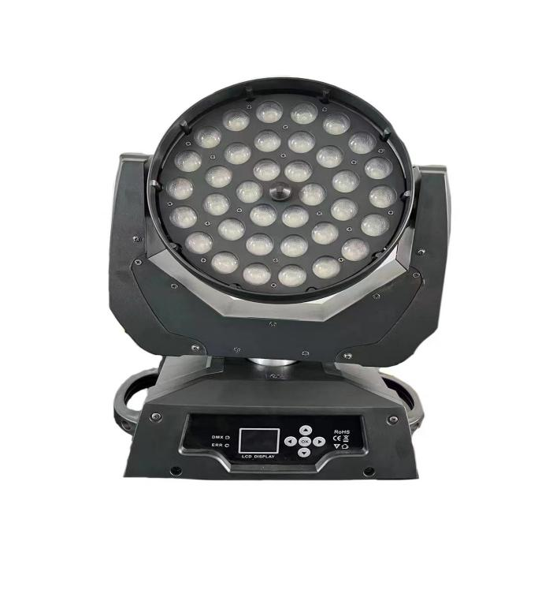

Please read the instructions carefully before use.

Product technical parameters:
Voltage: AC90-240v
Work rate: 400w
Frequency rate: 50-60Hz
Lamp beads: single 4 and 1 lamp beads
Access: 24CH / 16CH
Control mode: DMX/ master-slave / voice control
Horizontal scan: 540 °(16-bit accurate scan)
Vertical scan: 270 (16-bit accurate scan)
Stroboscopic: 1-25 per second or random
Display screen: LCD / English
Net weight: 7 kg.
Ruler: 38*31*46cm (carton 1in1)
1 address Set (DMX address setting)
This option is used to set the DMX address, press the "Enter" key to enter the setting, press the "UP" key to increase the address number, "DOWN" key can be the address number decline, select the address and press "Enter" to save the exit.
2U run Mode (Lamp working Mode setting)
This option is used to set the working mode of the lamp body, press the "Enter" key to enter the setting, or press the "UP" or "DOWN" key to select the working mode, which is followed by "DMX512", "Slow", "Fast", "Sound", and "Slave". Select work mode and press "Enter" to save exit.
DMX512: control station operation mode.
Slow: slow self-walking mode
Fast: fast self-walking mode
Sound sound control self-walking mode
Slave: slave mode
3 convert PAN (X axis reverse setting)
This option is to reverse the direction of the X axis, press the "Enter" key to enter the setting, press the "UP" key or "DOWN" key to select the X axis in reverse, select "Yes" to indicate the direction of the X axis, and select "NO" to indicate that the X-axis is not oriented. Select the direction and press "Enter" to save the exit.
4v convert TILT (Y axis reverse setting)
This option is to set the Y axis in reverse, press the "Enter" key to enter the setting, press the "UP" key or "DOWN" key to select the Y axis in reverse, select "Yes" to indicate the Y-axis direction, and select "NO" to indicate that the Y-axis is not oriented. Select the direction and press "Enter" to save the exit.
5 Display Set (LCD backlight setting)
This option is to display panel LCD backlight switch settings, press "Enter" key to enter settings, press "UP" or "DOWN" key to select backlight switch, select "Yes" to indicate that the LCD backlight has been long, not turned off, Select "NO" to indicate that no key operation is turned off for 20 seconds until it reopens. Select the mode and press "Enter" to save the exit.
6, Sound Sence (sound control sensitivity adjustment)
This option is to switch the lamp body voice sensitivity, press the "Enter" key to enter the setting, press the "UP" key or "DOWN" key to select the sensitivity of 0 ~ 100 degrees, select the sensitivity, then press "Enter" to save.
7, Factory Default (reverts to factory setting)
Users choose to restore factory settings, so the parameters will be set according to the product before the factory.
7t reset (lamp reset)
After the user chooses to reset, wait 3 seconds, the lamp body will be reset.
8 XY-Init Adjust (XY axis initial position fine-tuning setting)
After the user presses the "MENU" key for 5 seconds, the user will enter the XY axis initial position fine adjustment setting, press the "UP" key or "DOWN" key to adjust the initial position, determine the initial position and press "Enter" to save the exit.
9 White Balance (LED white balance setting)
After the user presses the “MENU” button for 5 seconds, it will enter the LED white balance setting. Press the “UP” button or the “DOWN” button to adjust the brightness of the red, blue, white and white colors. The options are “SET_R” and “SET_G” respectively. ""SET_B""SET_W", after confirming the color brightness, press "Enter" to save and exit.

15 channel mode:
Aisle
1 X axis (horizontal) 00255
2 Y axis (vertical) 000255
3 XY speed 000-255
4 total dimming 000-255
5 red (R first group 000255
6 Green G Group One| 000255
7 blue (B) the first group 00255
8 white (W first group 000255
9 stroboflash 000-255
10 focusing 000-255
11 function mode 000255
12 function mode speed| 000255
13 x axis fine-tuning 000255
14 Y-axis fine-tuning 000-255
15 Reset 1000249 invalid 250-255 reset
Thank you for using the products produced by our company for your safety
Fully effective use of this product
Before, please read this manual carefully and completely
Book. This manual contains: the performance of the product is very true
Minghe how to install it safely, and how important it is to use
For information, please keep it in a safe place for reference when using
Please strictly follow the relevant instructions when installing and using

