TARBOC
380/420 3in1 computer moving head light
Please read the instructions carefully before use
Instructions for use
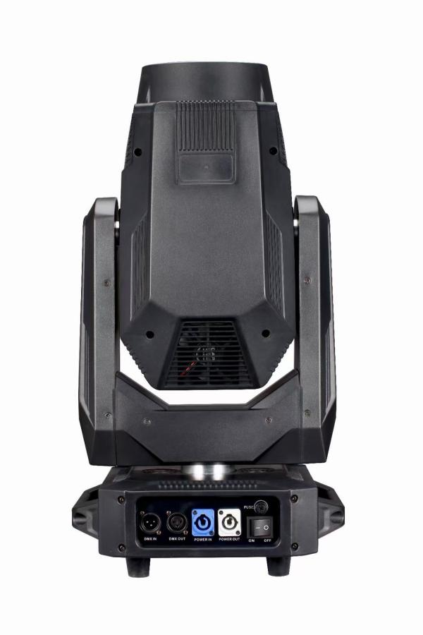


version number: MF 3.0

Directory
第1章 注意事项与安装 1
1. 维护保养 1
2. 声明 1
3. 产品注意事项 1
4. 灯具安装 1
第2章 面板操作 3
1. 概述 3
2. 操作 3
1. 使用直观触摸或编码器操作灯具 3
2. 参数数值输入 3
3. 设置布尔值参数 4
4. 子页面（参数） 4
3. 功能操作及参数设置 4
1. 设置DMX地址码 4
2. 设置灯具工作模式 5
3. 面板显示设置 5
4. 场景模式 6
5. 设置灯具工作参数 6
6. 查看灯具当前状态 7
第3章 通道描述 9
1. 通道表 9
第4章 常见故障及使用注意 13
1. 常见故障处理 13
2. 使用注意事项 13
3. RDM使用注意事项 14

NO.1 Precautions and Installation

Maintenance
- This lamp should be kept dry and avoid working in a humid environment.
- Intermittent use will effectively extend the life of the lamp.
- In order to obtain good ventilation and lighting effects, pay attention to cleaning the fan, fan net and lens frequently.
- Do not use alcohol and other organic solvents to wipe the lamp shell, so as not to cause damage.

Statement
This product in the factory into, the performance intact, complete packaging. All users should strictly follow the warnings and operating instructions stated above. Any damage caused by misuse is not within the company's guarantee, and the failure and problem caused by ignoring the operation manual are not within the scope of the dealer's responsibility.
This manual is subject to technical changes without notice.

Product considerations
- In order to ensure the service life of the product, this product should not be placed in a damp or leaking place, and should not work in an environment where the temperature exceeds 60 degrees.
- Do not place this product in a place that is easy to loosen or vibrate.
- In order to avoid the risk of electric shock, the maintenance of this product please seek professional maintenance.
- When the bulb is used, the power supply voltage change should not exceed ± 10%. If the voltage is too high, the life of the bulb will be shortened. If the voltage is too low, the light color of the bulb will be affected.
- After the power is off, it takes 20 minutes to use the lamp to fully cool down before it can be powered on again.
- In order to ensure the normal use of this product, please read this instruction carefully. Signal line connection (DMX)
Use RS-485 cable that meets specifications: shielded, 120ohm characteristic impedance, 22-24 AWG, low capacitive reactance. Do not use microphone cables or cables with different specified characteristics. The terminals must be connected using a 3-or 5-pin XLR type male/female connector. (1/4W minimum).
Important note: The wires cannot contact each other or the metal housing.
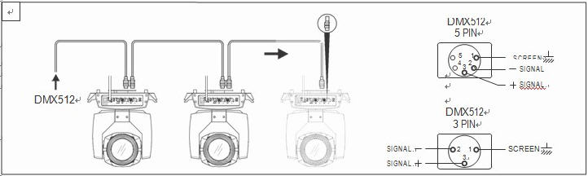
Figure Schematic 1diagram of DMX signal line connection

Installation of lamps
Luminaires can be placed horizontally, slanted and hung upside down. Be sure to pay attention to the installation method when hanging obliquely and upside down,.
As shown in theFig. 2Schematic diagram of , before positioning the lamp, to ensure the stability of the installation site, in the reverse hanging installation, must ensure that the lamp does not fall down on the support frame, need to use the safety rope through the support frame and lamp handle auxiliary hanging, to ensure safety,. Prevent the lamp from falling and sliding.
During the installation and commissioning of the lamps, pedestrians are prohibited from passing below, and the safety ropes are regularly checked for wear and the hook screws are loose.
If the hanging installation is not stable, resulting in all the consequences of falling lamps and lanterns, our company does not bear any responsibility.
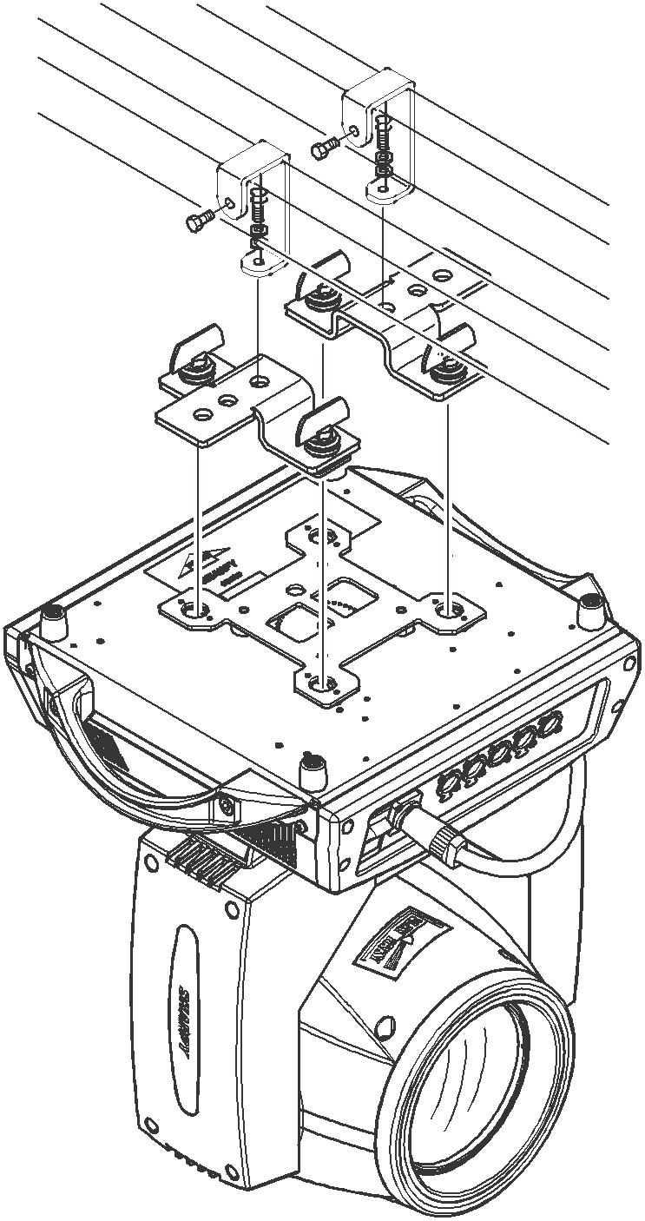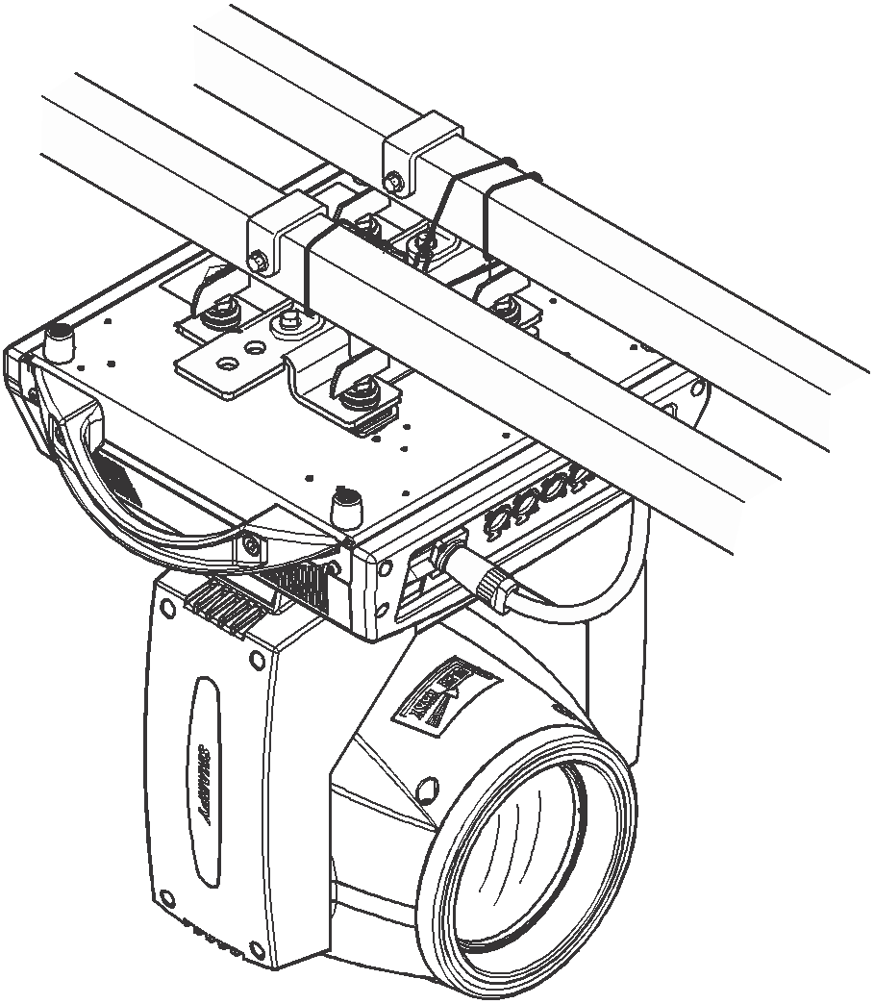
Fig. 2Schematic diagram of inverted lamp

NO.2 Panel Operation

Overview
The lamp panel diagram is shown inFigure 3Schematic diagram of , the title above shows the name of the lamp, and the status bar below shows the signal of the current lamp, the status of the bulb, and the fault (when the fault information is not checked, "ERR" is displayed, otherwise "NOR" is displayed), etc.
This lamp supports DMX/RDM protocol. When the lamp is searched by RDM host, the 3 letters "RDM" will appear on the panel to indicate that the lamp is enumerated normally.
The display and operation are similar to "Android operating system", which can be operated by clicking on the corresponding items with fingertips or blunt hard objects.
Note: Do not tap the display with a pointed or sharp object to prevent damage.
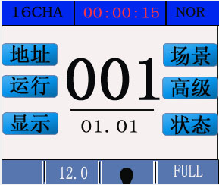
Figure 3Schematic diagram of display panel

Operation

Operate the of lamps using intuitive keys or encoders
- The left area is the TFT display area and touch area. Click the panel content with your finger or blunt hardware to complete the operation such as parameter setting or viewing status.
- The right area is auxiliary input. If you do not use the touch function provided by TFT, you can use auxiliary input to select items to be set or viewed to complete the operation.

Parameter value input
When the selected parameter item requires a value to be entered, the window shown in Figure 4will open:
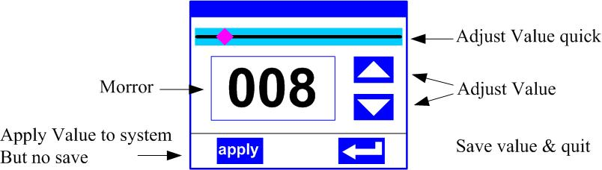
Figure 4Value Setting Page
- Set the value: you can directly pull the slider to quickly set the required value, or you can click the "up" or "down" button on the right to accurately set the required value or turn the "rotary encoder" on the right to set;
- Application value: when the data is set through the "up" or "down" button, and then press the "apply" application key in the lower left corner, the value will be sent to the lamp immediately, but the value is not saved;
- Save the value: click the "OK" button in the lower right corner at any time to save the current value to the internal storage, and the saved value will be applied to the lamp at the next boot.

Set boolean parameters
- When the set parameter is a Boolean value (such as ON or OFF), click the corresponding item directly to switch the parameter value, and the modified parameter will be saved to the internal storage. Press the parameter option on the right and the corresponding option will be grayed out. When hands are released, the corresponding parameters are changed and saved. If pressing the parameter option is not the parameter you want to change, then move your finger to another part of the screen and the corresponding parameter will not change.
- Important Boolean parameters are determined through the OK window, as shown belowFigure 5:
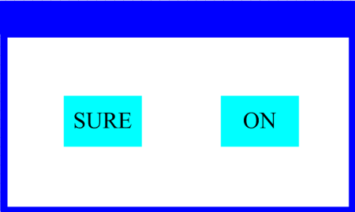
Figure 5determines the input window

Subpage (parameter)
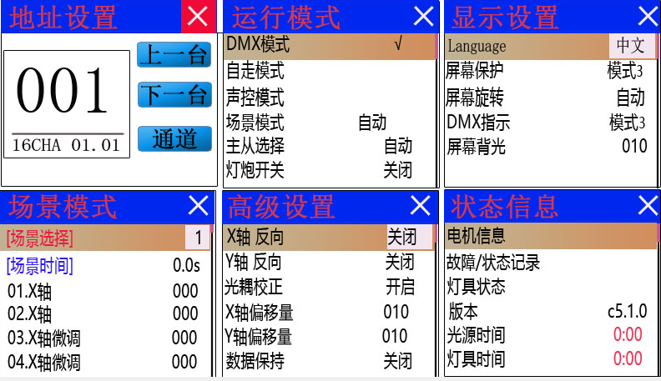
Figure 6 Function page

Function operation and parameter setting
Enter the setting interface, as shown in Figure 6:
- In the main interface, you can enter the corresponding parameter setting interface by selecting six buttons.
- In the parameter setting interface, you can press the blue option on the left to quickly switch to other setting interfaces.

Set DMX address code
The DMX address and channel mode of the lamp can be set on the page shown in Figure 6-1.
The menu setting of the lamp optimizes the setting of the address, and the operation of several setting address codes is as follows:
- Select "Previous" or "Next", the lamp will automatically calculate the address code of the next or previous one according to the current address code and channel data, which can be quickly set;
- Click the address code value to enter the value editing window, where any valid address code can be used. The lamp automatically obtains the current channel number of the lamp and automatically filters the unusable address code (512-current channel number).
- The lamp supports RDM protocol, and the address code of the lamp can be set remotely through RDM.
Two buttons are provided:
- Channel mode: different channel modes can be cyclically selected;
- Lamp reset: reset all motors.

Set lamp working mode
Through the page shown in Figure 6-2, the operation mode of the lamp can be set and the lamp gun can be controlled. The lamp supports 4 operation modes (DMX mode, self-walking mode, voice control mode and scene mode). Please refer to the previous section for detailed parameter value settings. The specific parameter descriptions are shown in the following table:
Operation mode
DMX mode | Console mode, receiving DMX signal, RDM signal
Self-walking mode | The lamp runs automatically according to the built-in program.
Voice Control Mode | When the lamp detects a strong sound, the lamp automatically runs a scene according to the built-in program, otherwise the last scene is maintained.
Scene Mode 01 | Run in the set scene mode and support custom editing of up to 10 scenes
Scene Mode 01 | 1 to 10 | Output the specified scene
Scene Mode 01 | Automatic | Automatically cycle output scenes in the sequence of the set scene time (not 0), and the scene with time 0 is automatically skipped and ignored.
Master-Slave Selection | It takes effect when it is not in DMX mode. Select the mode of data output. The lamp automatically detects the DMX state and automatically switches the output to prevent data conflicts.
Master-Slave Selection | Host | The lamp operates according to the built-in, if DMX has no signal, it will output data (synchronization), otherwise it will not output data
Master-Slave Selection | From machine | Lamps run as built-in, do not output data (not synchronized with other lamps)
Master-Slave Selection | Automatic | If there is no DMX signal, the lamp operates according to the built-in, otherwise, the lamp operates according to the DMX signal
Bulb switch | (Bulb light source) The confirmation dialog box pops up, select "SURE" to confirm the current operation, turn on or off the bulb, and the switch time interval is limited to 30 seconds.
Bulb switch | Close | Current bulb output is off
Bulb switch | Open | The current light output is already on
The scene mode is suitable for a single or a small number of lamps. It only needs to output a fixed scene or run a simple program. It can be edited in the scene page without connecting the console.
If the light source of the lamp is a bulb, please wait 10 minutes before turning on the bulb after turning off the bulb.

Panel display settings
The lamp supports bilingual Chinese and English, inverted display, etc., enter the corresponding parameter settings as shown in Figure 6-3, and the specific menu content is shown in the following table:
Display Settings
Language | Set the displayed language
Language | English | English Display
Language | Chinese | Chinese display
Screen Protection | Set the screen display content or mode after no operation for 30 seconds
Screen Protection | Close | Keep the last operation page, bright screen
Screen Protection | Mode 1 | OFF SCREEN
Screen Protection | Mode 2 | Black screen, the address code of the current lamp is displayed in the lower left corner
Screen Protection | Mode 3 | Display trademark information, address code and operation mode
Screen rotation | Set the orientation of the screen
Screen rotation | Close | do not reverse display
Screen rotation | Open | Reverse Display
Screen rotation | Automatic | Automatically detect the lamp hanging lamp direction, automatically switch the display direction
DMX indication | Setting the indication mode of the DMX signal indicator
DMX indication | Mode 1 | On when there is a signal, off when there is no signal
DMX indication | Mode 2 | When there is a signal, it goes off; when there is no signal, it goes on
DMX indication | Mode 3 | Flashing when there is a signal, off when there is no signal
Signal Indication Brightness | Set the brightness of the signal indicator
Signal Indication Brightness | 1 to 10 | 10 levels
screen backlight | Set the brightness of the screen backlight after 10 seconds of no operation, and it will be fully bright during operation.
screen backlight | 1 to 10 | 10 levels
Touch Screen Switch | Select whether to disable the touch screen, disable the touch function when the screen touch is accidentally damaged, use the auxiliary input to set the lamp
Touch correction | When the screen touch is inaccurate, you can enter the calibration page to correct the screen.
For lamps that support touch operation, if there is a bad touch phenomenon, you can enter the correction page to re-correct the touch accuracy of the touch screen. Under normal circumstances, please do not enter this page. If the touch is damaged, select Disable Touch.

Scene Mode
Enter the page shown in Figure 6-4, and the lamp enters the scene editing mode. Under this page, the lamp does not receive DMX console data, and the edited data is immediately reflected on the lamp.
The content of the page depends on the currently selected channel, and the displayed channel content and sequence are consistent with the lamp channel table. Through this page, you can edit 10 scenes, as shown in the following table:
Scene Mode
Scene Selection | Select the current operation scenario
Scene Selection | 1 to 10 | 10 Scene Settings
Scene Time | Set the retention time of the current scene in automatic time, unit: 0.1 seconds
Scene Time | 0 | The current scene does not participate in automatic scene output
Scene Time | 1-255 | 0 .. 1 second to 25.5 seconds
1. X axis | 0-255 | Set the data of each channel, and the display content and sequence correspond to the channel table of the lamp one by one.
...... | 0-255
...... | 0-255
N. Function | 0-255
If the valid reset data is edited in the reset channel in the scene, the lamp will be reset, but after reset, the value of the corresponding reset channel will be automatically cleared to prevent multiple consecutive resets.
View this page to obtain the current channel table sequence of lamps. For specific channel data, please refer to the detailed channel description.

Set lamp operating parameters
Enter the page shown in Figure 6-5, adjust the on-site parameters of lamps and lanterns, and facilitate the on-site installation of lamps and lanterns, etc:
Advanced Settings
X Axis Reverse | Set X-axis rotation direction
X Axis Reverse | Close | not reverse
X Axis Reverse | Open | Reverse
Y axis reverse | Set Y-axis rotation direction
Y axis reverse | Close | not reverse
Y axis reverse | Open | Reverse
optocoupler correction | Set whether the lamp detects XY out-of-step and corrects
optocoupler correction | Close | Position not corrected after step loss
optocoupler correction | Open | Automatic position correction after out-of-step
X-axis offset | Set the position of the X-axis zero point of the lamp
X-axis offset | 4-150
Y-axis offset | Set the position of the Y-axis zero point of the lamp
Y-axis offset | 4-48
Data retention | Set the output state of the lamp when the lamp has no DMX signal
Data retention | Close | There is no signal, so the motor and light source return to the position and state when the reset is completed
Data retention | Open | No signal, hold last 1 frame DMX data output
On mode | Set the way to turn on the bulb for the first time after power-on
On mode | Power on to open bubble | When power on, turn on the bulb first, and reset the lamp after 30 seconds
On mode | Bubble opening after reset | Reset the lamp after 3 seconds of power-on, and turn on the bulb after reset.
On mode | Manual bubble opening | After the reset is completed, manually turn on the bulb through the menu or the console
Factory Settings | A confirmation box will pop up. After selecting "SURE", the lamp parameters will return to the factory settings.
When the power-on bubble opening mode is selected, the lamp will wait for the bulb for 30 seconds after the lamp is powered on, so that the bulb can be fully started. After the internal voltage is stable enough, the reset procedure will be started again. If the power consumption capacity in the field is stable, the light bulb opening mode will be recommend.
When the position of the lamp cannot be corrected, please check whether the "optocoupler correction" is turned off first ".
When the signal is unplugged, if the position of the lamp is not as expected, please check the "data retention" setting first.
When setting the XY offset, after completing the setting, please control the XY with the maximum stroke first, so that after checking the setting, X Y will not hit the positioning rod or housing.

View current status of luminaires
Enter the page as shown in Figure 6-6, you can view the information and real-time status of lamps and lanterns, so as to know the use status of lamps and lanterns. If lamps and lanterns need after-sales, please provide the status information displayed on this page as the judgment basis, as shown in the following table:
Status Information
Motor Information | Displays the information status of all motors and signals within the luminaire
Motor Information | Hall | No display, it means that the motor has no Hall correction, 0 means that the motor leaves the correction position point, and 1 means that the motor is at the correction position point.
Motor Information | Status | Display motor reset completion status
Motor Information | X Axis | Displays the real-time position value of the X-axis optocoupler feedback
Motor Information | Y axis | Display real-time position value of Y-axis optocoupler feedback
Motor Information | optocoupler | Display X, Y axis optocoupler two signal level state, binary
Fault/Status Record | Display lamp reset and operation of the last 8 fault records
Fault/Status Record | Fault data | Total number of faults detected after power-up
Fault/Status Record | 12: 03 | Power-on time when a fault occurs, in minutes
Fault/Status Record | Hall fault | The motor does not detect a valid Hall signal when the corresponding motor is reset.
Fault/Status Record | Hall short circuit | When the corresponding motor is reset, the Hall signal of the motor is always valid.
Fault/Status Record | Optocoupler failure | No valid optocoupler signal detected when the corresponding motor is reset
Fault/Status Record | out of step | Corresponding motor loses step during operation
Fault/Status Record | Hit bar | Hit the positioning rod when the corresponding motor is reset.
Fault/Status Record | Bulb failure | Accidental extinction of bulb
Fault/Status Record | Sensor fault | The temperature sensor signal is abnormal,
Fault/Status Record | Fan fault | Main fan does not operate properly
Lamp status | Display the key status data of the current lamp for reference
Lamp status | Communication | 0~100%, the communication quality of the data link within the luminaire
Lamp status | Error Count | Total number of error frames detected after power-on, accumulated
Lamp status | Light source temperature | Display the temperature of the current light source, "---" means no detection.
Lamp status | Display panel temperature | Displays the temperature of the current display panel or nearby ambient temperature
Lamp status | Sensor 1 temperature | Displays the current motherboard temperature or the ambient temperature where the motherboard is installed
Version Information | Display the information and version of the current lamps and lanterns, an important reference for after-sales maintenance
Version Information | Equipment | The name of the lamp, the same as the equipment information of the RDM.
Version Information | Model | Model of luminaire, same as model information of RDM
Version Information | Display Panel | Firmware version and serial number of the display board
Version Information | Motherboard 1 | Firmware version and serial number of motherboard 1
Light source time | Record the total cumulative time spent on the light source, in minutes, which shall be manually cleared by the user as a reference for the regular maintenance of the light source.
Lamp time | Record the total cumulative time spent on the lamp, in minutes, which cannot be cleared.

NO.2 Channel Description

Channel Table
The sequence of the lamp channel can be viewed in the scene mode. The channel mode is set in the "Address Setting" page. The detailed data is shown in the following table:
Channel Table
Channel 1 | Channel 2 | Name | Numerical | Description
[CH1] | [CH1] | X Axis | 0-255 | 0-540 degrees
[CH2] |  | X Axis Trim | 0-255 | 0-2 degrees
[CH3] | [CH2] | Y axis | 0-255 | 0-270 degrees
[CH4] |  | Y-axis Trim | 0-255 | 0-1 degree
[CH5] | [CH3] | XY speed | 0-255 | From fast to slow
[CH6] | [CH4] | Reset/Function
[CH6] | [CH4] | Reset/Function | 0-99 | No function
[CH6] | [CH4] | Reset/Function | 100-105 | Turn off the bulb after 3 seconds
[CH6] | [CH4] | Reset/Function | 106-199 | No function
[CH6] | [CH4] | Reset/Function | 200-205 | 3 seconds after the light bulb
[CH6] | [CH4] | Reset/Function | 206-209 | No function
[CH6] | [CH4] | Reset/Function | 210-215 | Reset XY motor after 3 seconds
[CH6] | [CH4] | Reset/Function | 216-219 | No function
[CH6] | [CH4] | Reset/Function | 220-235 | Reset effect motor after 3 seconds
[CH6] | [CH4] | Reset/Function | 236-239 | No function
[CH6] | [CH4] | Reset/Function | 240-255 | Reset the whole lamp after 3 seconds
[CH7] | [CH5] | Color wheel
[CH7] | [CH5] | Color wheel | 0-129 | Linear Color
[CH7] | [CH5] | Color wheel | 130-134 | Color 1
[CH7] | [CH5] | Color wheel | 135-138 | Color 2
[CH7] | [CH5] | Color wheel | 139-143 | Color 3
[CH7] | [CH5] | Color wheel | 144-147 | Color 4
[CH7] | [CH5] | Color wheel | 148-152 | Color 5
[CH7] | [CH5] | Color wheel | 153-157 | Color 6
[CH7] | [CH5] | Color wheel | 158-161 | Color 7
[CH7] | [CH5] | Color wheel | 162-166 | Color 8
[CH7] | [CH5] | Color wheel | 167-171 | Color 9
[CH7] | [CH5] | Color wheel | 172-210 | Fast to slow forward flowing water
[CH7] | [CH5] | Color wheel | 211-215 | Stop
[CH7] | [CH5] | Color wheel | 216-255 | Reverse flow from slow to fast
[CH8] |  | Color wheel trimming | 0-255
[CH9] | [CH6] | Figure
[CH9] | [CH6] | Figure | 0-4 | Pattern 1
[CH9] | [CH6] | Figure | 5-9 | Pattern 2
[CH9] | [CH6] | Figure | 10-14 | Pattern 3
[CH9] | [CH6] | Figure | 15-19 | Pattern 4
[CH9] | [CH6] | Figure | 20-24 | Pattern 5
[CH9] | [CH6] | Figure | 25-29 | Pattern 6
[CH9] | [CH6] | Figure | 30-34 | Pattern 7
[CH9] | [CH6] | Figure | 35-39 | Pattern 8
[CH9] | [CH6] | Figure | 40-44 | Pattern 9
[CH9] | [CH6] | Figure | 45-49 | white light
[CH9] | [CH6] | Figure | 50-54 | Dither pattern 1 from slow to fast
[CH9] | [CH6] | Figure | 55-59 | Dither pattern 2 from slow to fast
[CH9] | [CH6] | Figure | 60-64 | Dither pattern 3 from slow to fast
[CH9] | [CH6] | Figure | 65-69 | Dither pattern 4 from slow to fast
[CH9] | [CH6] | Figure | 70-74 | Dither pattern 5 from slow to fast
[CH9] | [CH6] | Figure | 75-79 | Dither pattern from slow to fast 6
[CH9] | [CH6] | Figure | 80-84 | Dither pattern from slow to fast 7
[CH9] | [CH6] | Figure | 85-89 | Dither pattern from slow to fast 8
[CH9] | [CH6] | Figure | 90-94 | Dither pattern from slow to fast 9
[CH9] | [CH6] | Figure | 95-177 | Fast to slow forward flowing water
[CH9] | [CH6] | Figure | 178-180 | Stop
[CH9] | [CH6] | Figure | 181-255 | Reverse flow from slow to fast
[CH10] | [CH7] | Rotating chart
[CH10] | [CH7] | Rotating chart | 0-7 | white light
[CH10] | [CH7] | Rotating chart | 8-15 | Pattern 1
[CH10] | [CH7] | Rotating chart | 16-23 | Pattern 2
[CH10] | [CH7] | Rotating chart | 24-31 | Pattern 3
[CH10] | [CH7] | Rotating chart | 32-39 | Pattern 4
[CH10] | [CH7] | Rotating chart | 40-47 | Pattern 5
[CH10] | [CH7] | Rotating chart | 48-55 | Pattern 6
[CH10] | [CH7] | Rotating chart | 56-63 | Pattern 7
[CH10] | [CH7] | Rotating chart | 64-71 | Dither pattern 1 from slow to fast
[CH10] | [CH7] | Rotating chart | 72-79 | Dither pattern 2 from slow to fast
[CH10] | [CH7] | Rotating chart | 80-87 | Dither pattern 3 from slow to fast
[CH10] | [CH7] | Rotating chart | 88-95 | Dither pattern 4 from slow to fast
[CH10] | [CH7] | Rotating chart | 96-103 | Dither pattern 5 from slow to fast
[CH10] | [CH7] | Rotating chart | 104-111 | Dither pattern from slow to fast 6
[CH10] | [CH7] | Rotating chart | 112-119 | Dither pattern from slow to fast 7
[CH10] | [CH7] | Rotating chart | 120-185 | Fast to slow forward flowing water
[CH10] | [CH7] | Rotating chart | 186-189 | Stop
[CH10] | [CH7] | Rotating chart | 190-255 | Reverse flow from slow to fast
[CH11] | [CH8] | chart rotation
[CH11] | [CH8] | chart rotation | 0-127 | 0-360 degrees
[CH11] | [CH8] | chart rotation | 128-190 | Reverse flow from fast to slow
[CH11] | [CH8] | chart rotation | 191-192 | Stop
[CH11] | [CH8] | chart rotation | 193-255 | Slow to fast forward flowing water
[CH12] |  | Plate Trim | 0-255
[CH13] | [CH9] | Prism 1
[CH13] | [CH9] | Prism 1 | 0-63 | None
[CH13] | [CH9] | Prism 1 | 64-127 | Insert Prism 1
[CH13] | [CH9] | Prism 1 | 128-191 | Insert Prism 2
[CH13] | [CH9] | Prism 1 | 192-255 | Insert prism 1 + prism 2
[CH14] | [CH10] | prism rotation
[CH14] | [CH10] | prism rotation | 0-127 | 0-360 degrees
[CH14] | [CH10] | prism rotation | 128-187 | Fast to slow forward flowing water
[CH14] | [CH10] | prism rotation | 188-195 | Stop
[CH14] | [CH10] | prism rotation | 196-255 | Reverse flow from slow to fast
[CH15] | [CH11] | Prism 2 rotation
[CH15] | [CH11] | Prism 2 rotation | 0-127 | 0-360 degrees
[CH15] | [CH11] | Prism 2 rotation | 128-187 | Fast to slow forward flowing water
[CH15] | [CH11] | Prism 2 rotation | 188-195 | Stop
[CH15] | [CH11] | Prism 2 rotation | 196-255 | Reverse flow from slow to fast
[CH16] | [CH12] | atomization
[CH16] | [CH12] | atomization | 0-127 | None
[CH16] | [CH12] | atomization | 128-255 | atomization
[CH17] | [CH13] | Zoom in | 0-255 | From large to small
[CH18] |  | Magnification Trim | 0-255
[CH19] | [CH14] | Focus | 0-255 | from far to near
[CH20] |  | Focus Fine Adjustment | 0-255
[CH21] |  | Effect | 0-255
[CH22] | [CH15] | Strobe
[CH22] | [CH15] | Strobe | 0-3 | Turn off the light
[CH22] | [CH15] | Strobe | 4-103 | From slow to fast pulse strobe
[CH22] | [CH15] | Strobe | 104-107 | Switch
[CH22] | [CH15] | Strobe | 108-207 | Gradient strobe from slow to fast
[CH22] | [CH15] | Strobe | 208-212 | Switch
[CH22] | [CH15] | Strobe | 213-251 | From slow to fast random strobe
[CH22] | [CH15] | Strobe | 252-255 | Switch
[CH23] | [CH16] | Dimming | 0-255 | 0-100% dimming
[CH24] |  | Dimming Trim | 0-255

Common faults and use attention

Common fault handling
Lamps contain microcomputer circuit boards, high-voltage power supplies and other professional components, for your safety and product life, non-professionals do not disassemble lamps and related accessories without authorization.

Bulb does not light (except LED light source)
Possible cause: The bulb has not completely cooled, or the bulb has reached the end of its life. Deal with it as follows:
- Due to abnormal operation, the bulb is not completely cooled, the lamp body should be allowed to cool for more than 10 minutes, so that its interior is completely restored to normal state, and then start the power supply again;
- Check whether the bulb has reached the service life, and replace it with a new bulb;
- Check the circuit between the bulb and the lighter for electric leakage, falling off or poor contact;
- Replace with a new lighter.

The beam appears dim
Possible causes: the bulb has been used for a long time or the light path is not clean. The treatment is as follows:
- Check whether the bulb has reached the service life, and replace it with a new bulb;
- Check whether the optical parts or bulbs are clean, whether there is dust on the bulbs and other optical devices, and clean and maintain the bulbs and components in the lamps regularly.

Pattern projection blur
- Check whether the electronic focus channel value is suitable for the current projection distance.

Lamps work intermittently
The possible reason: the internal line enters the protection state, and the treatment is as follows:
- Check whether the fan is running normally or dirty, causing the internal temperature of the lamp to rise;
- Check whether the internal temperature control switch is closed;
- Check whether the bulb has reached the end of its service life and replace it with a new bulb.

The lamp does not accept the control of the console after normal reset.
Possible causes: signal line failure or lamp parameter setting is not normal, the treatment is as follows:
- Check the starting address code and check the connection of DMX signal line (whether the signal line cable is intact and whether the connection of the front is loose);
- Add signal amplifier and 120 ohm terminal resistance;

Luminaire cannot be started
Possible cause: poor power supply line, handled as follows:
- Check if the fuse on the power input receptacle is blown, and replace the fuse;
- Poor line contact due to vibration of lamps in long-distance transportation
- Check the input power supply, computer board and other plug devices.

Precautions for use
- Check whether the local power supply meets the requirements of the rated voltage of the product, and whether the leakage protector and overcurrent protector meet the requirements of the load;
- Do not use the power cord whose insulation is damaged, and do not connect the power cord to other wires;
- The lamp adopts strong wind refrigeration, which is easy to accumulate dust. It must be cleaned once a month, especially the heat dissipation outlet, otherwise it will be blocked by dust accumulation, resulting in poor heat dissipation and abnormal lamps.
- When installing lamps and lanterns, the fixing screws must be tightened, and safety cables must be added, and regular inspection;
- During the installation and positioning of the lamp, the minimum distance between any point on the surface of the lamp and any combustible and explosive objects shall be 10 meters, and the distance from the irradiated object shall be 2.5 meters. Please do not install the lamp directly on the surface of combustible substances;
- It is recommended that the continuous working time of the lamp should not exceed 10 hours, and the interval between continuous starting of the lamp should not be less than 10 minutes, otherwise it will not be triggered normally due to the overheating protection of the lamp;
- The closing time of the on-off valve should not exceed 5 minutes. If the light needs to be closed for a long time, the light gun should be closed by the control console (light gun control channel);
- In order to ensure that multiple lamps can better comply with the scene effect, the lamps should not always be in the current scene, that is, start the next scene action, preferably this state should not exceed 3 minutes, to ensure that multiple lamps can operate synchronously;
- In the process of use, if the lamp is abnormal, stop using the lamp in time to prevent other faults.

RDM Use Precautions
RDM is an extended version of DMX512-A protocol. It is a remote device management (Remote Device Management) protocol. Traditional DMX512 protocol communication is one-way communication. The protocol is based on RS-485 bus. The RS-485 is time-sharing multipoint and half-duplex protocol. Only one port is allowed to be output by the host at the same time. Therefore, the following points should be noted when using RDM:
- To use a console or host device that supports the RDM protocol host;
- To use two-way signal amplifier, the traditional one-way signal amplifier does not apply RDM protocol, because the RMD protocol needs feedback data, the use of one-way amplifier will block the returned data, resulting in the search of lamps and lanterns;
- The lamp must be set to DMX mode to ensure that there is only one host on the signal line;
- A 120ohm impedance matching resistor must be inserted between terminals 2 and 3 of the terminal plug. When the signal line is relatively long, the differential signal will be used more stably, which is conducive to the quality of communication;
- When there is a lamp that accepts DMX control, but cannot RDM search for the lamp, first check the signal amplifier, and then check whether there is a bad line contact between the 2 and 3 lines of the signal line.

Product Warranty Card

Product Name ----------------------- Product Model----------------------
Date of Manufacture---------------------

End User
Name of the unit; | Contact:
Address: | Telephone:
Dealer
Contact: | Telephone:

Packing size: 66.5cm * 32cm * 40cm
Gross weight: 18KG

