TARBOC
New private model 295W beam lamp
Instructions for use
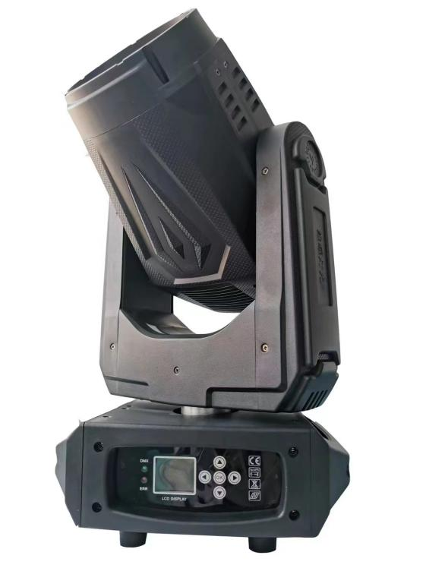

Version number: MF 3.0

Precautions and Installation

Maintenance
- This lamp should be kept dry and avoid working in a humid environment.
- Intermittent use will effectively extend the life of the lamp.
- In order to obtain good ventilation and lighting effects, pay attention to cleaning the fan, fan net and lens frequently.
- Do not use alcohol and other organic solvents to wipe the lamp shell, so as not to cause damage.

Statement
This product in the factory into, the performance intact, complete packaging. All users should strictly follow the warnings and operating instructions stated above,
Any damage caused by misuse is not within the company's guarantee, and the failure and problem caused by ignoring the operation manual are not within the scope of the dealer's responsibility.
This manual is subject to technical changes without notice.

Product considerations
- In order to ensure the service life of the product, this product should not be placed in a damp or leaking place, and should not work in an environment where the temperature exceeds 60 degrees.
- Do not place this product in a place that is easy to loosen or vibrate.
- In order to avoid the risk of electric shock, the maintenance of this product please seek professional maintenance.
- When the bulb is used, the power supply voltage change should not exceed ± 10%. If the voltage is too high, the life of the bulb will be shortened. If the voltage is too low, the light color of the bulb will be affected.
- After the power is off, it takes 20 minutes to use the lamp to fully cool down before it can be powered on again.
- In order to ensure the normal use of this product, please read this instruction carefully. Signal line connection (DMX)
Use RS-485 cable that meets specifications: shielded, 120ohm characteristic impedance, 22-24 AWG, low capacitive reactance. Do not use microphone cables or cables with different specified characteristics. The terminals must be connected using a 3-or 5-pin XLR type male/female connector. (1/4W minimum).
Important note: The wires cannot contact each other or the metal housing.
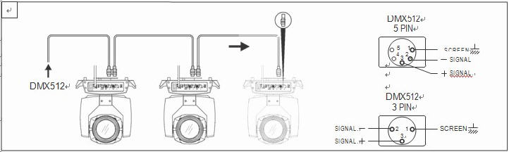
Figure 1DMX signal line connection diagram

Installation of lamps
Luminaires can be placed horizontally, slanted and hung upside down. Be sure to pay attention to the installation method when hanging obliquely and upside down.
As Fig. 2Inverted lamp of shown, in the lamp positioning, to ensure that the installation site of stability, in the reverse hanging installation,
It must be ensured that the lamp does not fall on the support frame, and the safety rope needs to pass through the support frame and the lamp handle for auxiliary hanging,
To ensure safety and prevent lamps from falling and sliding.
During the installation and commissioning of the lamps, pedestrians are prohibited from passing below, and the safety ropes are regularly checked for wear and the hook screws are loose.
If the hanging installation is not stable, resulting in all the consequences of falling lamps and lanterns, our company does not bear any responsibility.
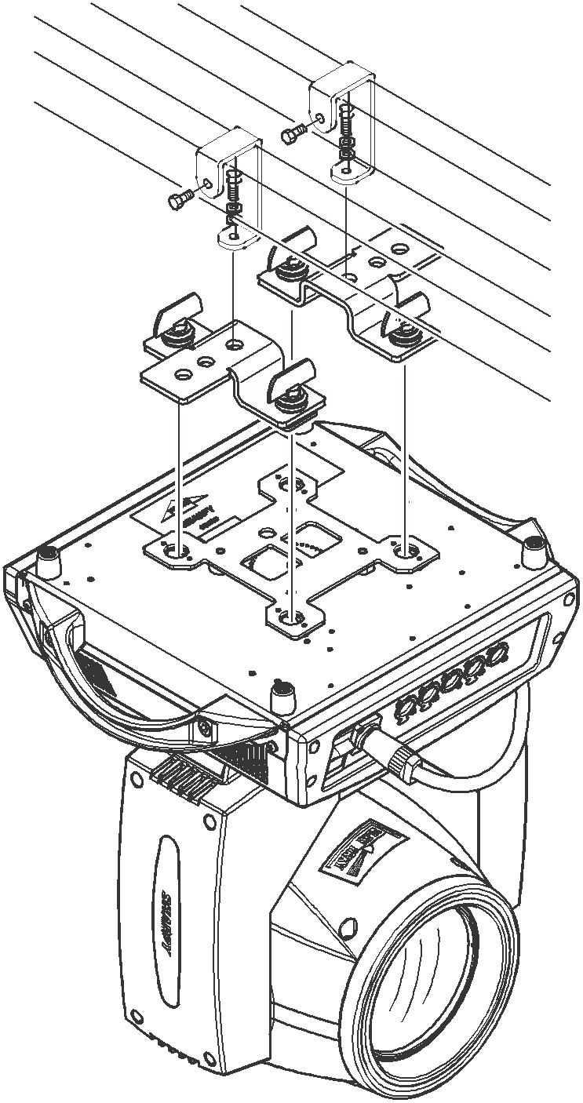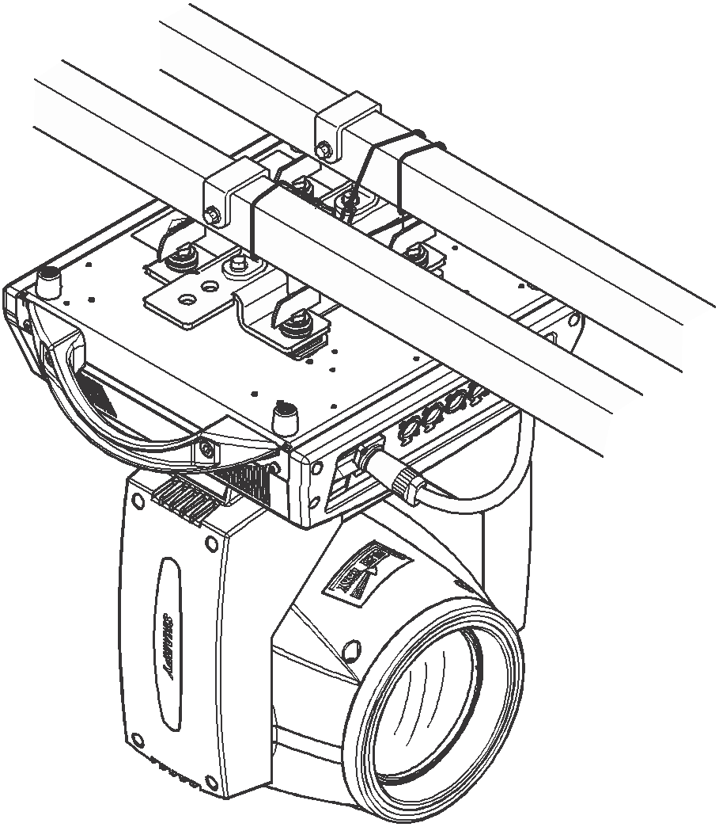
Fig. 2Inverted lamp of

Main Menu | Submenu | Menu function description
1. System Settings | 1. DMX Address | Modify DMX address code up or down (address code can be selected from 001-512), confirm key to save, default 001.
1. System Settings | 2. Encoder | Up or down to modify the encoder to open/close, confirm the key to save, the default to open.
1. System Settings | 3, X reversal | Up or down to modify the X reverse open/close, confirm the key to save, the default closed.
1. System Settings | 4. Y reversal | Up or down to modify the Y reverse open/close, confirm the key to save, the default closed.
1. System Settings | 5, no signal | Hold/Clear
1. System Settings | 6, boot bright gun bubble | ON/OFF
1. System Settings | 7. Reset | ON/OFF
1. System Settings | 8. Advanced Settings
2. Operation mode | 1. Operation mode | Up or down to select the operation mode DMX/voice control/automatic, confirm the key to save, the default DMX.
2. Operation mode | 2. Channel selection | Up or down select channel CH16.CH18 to confirm the key to save. Default CH16
3. Manual control | 1. Color wheel | Modify up and down values 000-255 default 000
3. Manual control | 2. Strobe | Modify up and down values 000-255 default 000
3. Manual control | 3. Dimming | Modify up and down values 000-255 default 000
3. Manual control | 4. Pattern plate | Modify up and down values 000-255 default 000
3. Manual control | 5. Prism 1 | Modify up and down values 000-255 default 000
3. Manual control | 6. Prism 1 Rotation | Modify up and down values 000-255 default 000
3. Manual control | 7. Prism 2 | Modify up and down values 000-255 default 000
3. Manual control | 8. Prism 2 Rotation | Modify up and down values 000-255 default 000
3. Manual control | 9, focusing | Modify up and down values 000-255 default 000
3. Manual control | 10. X-axis | Modify up and down values 000-255 default 000
3. Manual control | 11. X-axis fine adjustment | Modify up and down values 000-255 default 000
3. Manual control | 12. Y axis | Modify up and down values 000-255 default 000
3. Manual control | 13. Y-axis fine adjustment | Modify up and down values 000-255 default 000
3. Manual control | 14. XY speed | Modify up and down values 000-255 default 000
3. Manual control | 15. Atomization | Modify up and down values 000-255 default 000
3. Manual control | 16, colorful. | Modify up and down values 000-255 default 000
3. Manual control | 17. Bulb Control | Modify up and down values 000-255 default 000
3. Manual control | 18. Reset | Modify up and down values 000-255 default 000
4. Display Settings | 1. Language selection | Up or down to select Chinese/EN (English), confirm the key to save, the default Chinese.
4. Display Settings | 2. Inverted display setting | Select up or down to turn off/turn on the reverse display setting, confirm the key to save, and turn off by default.
4. Display Settings | 3, screen protection | Mode 1-Mode 4
4. Display Settings | 4. DMX index | Mode 1-Mode 4
4. Display Settings | 5. Backlight display | 010
5. Factory setting  4, | Please enter the password! Change up or down to 138, and then press the Enter key to enter the factory setup.  4, | 1. X-axis calibration | Modify parameters up or down (range 000-255), confirm key save, default 128.
5. Factory setting  4, |  | 2. Y-axis calibration | Modify parameters up or down (range 000-255), confirm key save, default 128.
5. Factory setting  4, |  | 3. Color wheel calibration | Modify parameters up or down (range 000-255), confirm key save, default 128.
5. Factory setting  4, |  | 4. Solid diagram calibration | Modify parameters up or down (range 000-255), confirm key save, default 128.
5. Factory setting  4, |  | 5. Strobe calibration | Modify parameters up or down (range 000-255), confirm key save, default 128.
5. Factory setting  4, |  | 6. Strobe stroke | Modify parameters up or down (range 000-255), confirm key save, default 128.
5. Factory setting  4, |  | 7. Strobe half step | Modify parameters up or down (range 000-255), confirm key save, default 128.
5. Factory setting  4, |  | 8. Focus Calibration | Modify parameters up or down (range 000-255), confirm key save, default 128.
5. Factory setting  4, |  | 9. Focusing stroke | Modify parameters up or down (range 000-255), confirm key save, default 128.
5. Factory setting  4, |  | 10. Prism 1 stroke | Modify parameters up or down (range 000-255), confirm key save, default 128.
5. Factory setting  4, |  | 11. Prism 1 Half Step | Modify parameters up or down (range 000-255), confirm key save, default 128.
5. Factory setting  4, |  | 12. Prism 2 stroke | Modify parameters up or down (range 000-255), confirm key save, default 128.
5. Factory setting  4, |  | 13. Prism 2 Half Step | Modify parameters up or down (range 000-255), confirm key save, default 128.
5. Factory setting  4, |  | 14. Atomization stroke | Modify parameters up or down (range 000-255), confirm key save, default 128.
5. Factory setting  4, |  | 15, atomization half step | Modify parameters up or down (range 000-255), confirm key save, default 128.
5. Factory setting  4, |  | 16, colorful itinerary | Modify parameters up or down (range 000-255), confirm key save, default 128.
5. Factory setting  4, |  | 17, colorful half step | Modify parameters up or down (range 000-255), confirm key save, default 128.
5. Factory setting  4, |  | 18. Dynamic drawing calibration | Modify parameters up or down (range 000-255), confirm key save, default 128.
5. Factory setting  4, |  | 19. Dynamic chart rotation calibration | Modify parameters up or down (range 000-255), confirm key save, default 128.
5. Factory setting  4, |  | 20. Amplification Calibration | Modify parameters up or down (range 000-255), confirm key save, default 128.
5. Factory setting  4, |  | 21. Enlarged stroke | Modify parameters up or down (range 000-255), confirm key save, default 128.
5. Factory setting  4, |  | 22. Uniform light stroke | Modify parameters up or down (range 000-255), confirm key save, default 128.
5. Factory setting  4, |  | 23, uniform light half step | Modify parameters up or down (range 000-255), confirm key save, default 128.
5. Factory setting  4, |  | 24. Aperture stroke | Modify parameters up or down (range 000-255), confirm key save, default 128.
5. Factory setting  4, |  | 25, aperture half step | Modify parameters up or down (range 000-255), confirm key save, default 128.
5. Factory setting  4, |  | 26. CMY1 Calibration | Modify parameters up or down (range 000-255), confirm key save, default 128.
5. Factory setting  4, |  | 27. CMY2 calibration | Modify parameters up or down (range 000-255), confirm key save, default 128.
5. Factory setting  4, |  | 28. CMY3 calibration | Modify parameters up or down (range 000-255), confirm key save, default 128.
5. Factory setting  4, |  | 28. Fine adjustment 1 | Modify parameters up or down (range 000-255), confirm key save, default 128.
5. Factory setting  4, |  | 29. Fine adjustment 2 | Modify parameters up or down (range 000-255), confirm key save, default 128.
5. Factory setting  4, |  | 30. Fine adjustment 3 | Modify parameters up or down (range 000-255), confirm key save, default 128.
5. Factory setting  4, |  | 31. Fine adjustment 4 | Modify parameters up or down (range 000-255), confirm key save, default 128.
5. Factory setting  4, |  | 32. X speed | Modify parameters up or down (range 000-255), confirm key save, default 128.
5. Factory setting  4, |  | 33. X stroke | Modify parameters up or down (range 000-255), confirm key save, default 128.
5. Factory setting  4, |  | 34. X current | Modify parameters up or down (range 000-255), confirm key save, default 128.
5. Factory setting  4, |  | 35. Y speed | Modify parameters up or down (range 000-255), confirm key save, default 128.
5. Factory setting  4, |  | 36. Y stroke | Modify parameters up or down (range 000-255), confirm key save, default 128.
5. Factory setting  4, |  | 37. Y current | Modify parameters up or down (range 000-255), confirm key save, default 128.
5. Factory setting  4, |  | 38. Fan speed | 7000
5. Factory setting  4, |  | 39. Time Clearing | Yes/No
5. Factory setting  4, |  | 40, half power | ON/OFF
5. Factory setting  4, |  | 41. Fan Control | ON/OFF
5. Factory setting  4, |  | 42, Logo | 000

CH16 (Detailed Channel Table)
Channel | Function | Channel Value
1 | Color disc | 0 - 9  10 - 14  15 - 19  20 - 24  24 - 29  30 - 34  35 - 39  40 - 44  45 - 49  50 - 54  55 - 59  60 - 64  65 - 69  70 - 74  75 - 79  80 - 84  85 - 89  90 - 94  95 -99  100-104  105-109  110-114  115-119  120-124  125-129  130-134  135-139  140-149  150-203  204-255 | Color 1  Color 1 + Color 2  Color 2  Color 2 + Color 3  Color 3  Color 3 + Color 4  Color 4  Color 4 + Color 5  Color 5  Color 5 + Color 6  Color 6  Color 6 + Color 7  Color 7  Color 7 + Color 8  Color 8  Color 8 + Color 9  Color 9  Color 9 + Color 10  Color 10  Color 10 + Color 11  Color 11  Color 11 + Color 12  Color 12  Color 12 + Color 13  Color 13  Color 13 + Color 14  Color 14  Color 14 + Color 1  Forward flow (from fast to slow)  Reverse flow (from slow to fast)
2 | Strobe | 0 - 3  4 -103  104-107  108-207  209-212  213-251  252-255 | closed light  Pulse strobe (from slow to fast)  open light  Effect strobe (slow to fast)  open light  Random strobe (slow to fast)  open light
3 | Dimming | 0-255 | From dark to light
4 | pattern plate | 0 - 5  6 - 11  12 - 17  18 - 23  24 - 29  30 - 35  36 - 41  42 - 47  48 - 53  54 - 59  60 - 65  66 - 71  72 - 77  78 - 83  84 - 89  90-134  135-139  140-185  186-190  191-195  196-200  201-205  206-210  211-215  216-220  221-225  226-230  231-235  236-240  241-245  246-250  251-255 | Solid Figure 1  Solid Figure 2  Solid Figure 3  Solid Figure 4  Solid Figure 5  Solid Figure 6  Solid Figure 7  Solid Figure 8  Solid Figure 9  Solid Figure 10  Solid Figure 11  Fixed Figure 12  Fixed Figure 13  Fixed Figure 14  Fixed Figure 15  Forward flow (from fast to slow)  Solid Figure 1  Reverse flow (from slow to fast)  Figure 2 Jitter (from slow to fast)  Figure 3 Jitter (from slow to fast)  Figure 4 Jitter (from slow to fast)  Figure 5 Jitter (from slow to fast)  Figure 6 Jitter (from slow to fast)  Figure 7 Jitter (from slow to fast)  Figure 8 Jitter (from slow to fast)  Figure 9 Jitter (from slow to fast)  Figure 10 Jitter (from slow to fast)  Figure 11 Jitter (from slow to fast)  Figure 12 Jitter (from slow to fast)  Figure 13 Jitter (from slow to fast)  Figure 14 Jitter (from slow to fast)  Figure 15 Jitter (from slow to fast)
5 | Prism 1 | 000-127  128-255 | Prism 1 pop-up  Prism 1 cut-in
6 | Prism 12 rotation | 000-064  065-127  128-191  192-255 | Index  Forward running water (from slow to fast  Reverse flow (from slow to fast)  Positive and negative turn (from slow to fast)
7 | Prism 2 | 000-127  128-255 | Prism 2 pop-up  Prism 2 Cut
8 | atomization | 000-255 | 128-255 Atomizer Cut-in
9 | Focus | 000-255 | Pattern clarity from far to near
10 | X | 000-255 | Horizontal 540 degree scanning
11 | X Trim | 000-255 | Horizontal 1.2 Trim
12 | Y | 000-255 | Vertical 270 degree scan
13 | Y Trim | 000-255 | Vertical 1.2 Trim
14 | XY speed | 0-255 | From fast to slow
15 | Colorful | 0-255 | 0-127 colorful mirror pops up  128-255 Colorful Mirror Cut In
16 | On/Reset | 0-255 | 0-99 No effect  100-105 Turn off the bulb  106-199 No effect  200-205 light bulb  206-255 RESET

Channel Table
CH18 (Detailed Channel Table)
Channel | Function | Channel Value
1 | Color disc | 0 - 9  10 - 14  15 - 19  20 - 24  24 - 29  30 - 34  35 - 39  40 - 44  45 - 49  50 - 54  55 - 59  60 - 64  65 - 69  70 - 74  75 - 79  80 - 84  85 - 89  90 - 94  95 -99  100-104  105-109  110-114  115-119  120-124  125-129  130-134  135-139  140-149  150-203  204-255 | Color 1  Color 1 + Color 2  Color 2  Color 2 + Color 3  Color 3  Color 3 + Color 4  Color 4  Color 4 + Color 5  Color 5  Color 5 + Color 6  Color 6  Color 6 + Color 7  Color 7  Color 7 + Color 8  Color 8  Color 8 + Color 9  Color 9  Color 9 + Color 10  Color 10  Color 10 + Color 11  Color 11  Color 11 + Color 12  Color 12  Color 12 + Color 13  Color 13  Color 13 + Color 14  Color 14  Color 14 + Color 1  Forward flow (from fast to slow)  Reverse flow (from slow to fast)
2 | Strobe | 0 - 3  4 -103  104-107  108-207  209-212  213-251  252-255 | closed light  Pulse strobe (from slow to fast)  open light  Effect strobe (slow to fast)  open light  Random strobe (slow to fast)  open light
3 | Dimming | 0-255 | From dark to light
4 | pattern plate | 0 - 5  6 - 11  12 - 17  18 - 23  24 - 29  30 - 35  36 - 41  42 - 47  48 - 53  54 - 59  60 - 65  66 - 71  72 - 77  78 - 83  84 - 89  90-134  135-139  140-185  186-190  191-195  196-200  201-205  206-210  211-215  216-220  221-225  226-230  231-235  236-240  241-245  246-250  251-255 | Solid Figure 1  Solid Figure 2  Solid Figure 3  Solid Figure 4  Solid Figure 5  Solid Figure 6  Solid Figure 7  Solid Figure 8  Solid Figure 9  Solid Figure 10  Solid Figure 11  Fixed Figure 12  Fixed Figure 13  Fixed Figure 14  Fixed Figure 15  Forward flow (from fast to slow)  Solid Figure 1  Reverse flow (from slow to fast)  Figure 2 Jitter (from slow to fast)  Figure 3 Jitter (from slow to fast)  Figure 4 Jitter (from slow to fast)  Figure 5 Jitter (from slow to fast)  Figure 6 Jitter (from slow to fast)  Figure 7 Jitter (from slow to fast)  Figure 8 Jitter (from slow to fast)  Figure 9 Jitter (from slow to fast)  Figure 10 Jitter (from slow to fast)  Figure 11 Jitter (from slow to fast)  Figure 12 Jitter (from slow to fast)  Figure 13 Jitter (from slow to fast)  Figure 14 Jitter (from slow to fast)  Figure 15 Jitter (from slow to fast)
5 | Prism 1 | 000-127  128-255 | Prism 1 pop-up  Prism 1 cut-in
6 | Prism 1 rotation | 000-064  065-127  128-191  192-255 | Index  Forward running water (from slow to fast  Reverse flow (from slow to fast)  Positive and negative turn (from slow to fast)
7 | Prism 2 | 000-127  128-255 | Prism 2 pop-up  Prism 2 Cut
8 | Prism 1 rotation | 000-064  065-127  128-191  192-255 | Index  Forward running water (from slow to fast  Reverse flow (from slow to fast)  Positive and negative turn (from slow to fast)
9 | Focus | 000-255 | Pattern clarity from far to near
10 | X Axis | 000-255 | Horizontal 540 degree scanning
11 | X Axis Trim | 000-255 | Horizontal 1.2 Trim
12 | Y axis | 000-255 | Vertical 270 degree scan
13 | Y-axis Trim | 000-255 | Vertical 1.2 Trim
14 | XY speed | 000-255 | From fast to slow
15 | atomization | 0-255 | 128-255 Atomizer Cut-in
16 | Colorful | 0-255 | 0-127 colorful mirror pops up  128-255 Colorful Mirror Cut In
17 | Lamp ignition and lamp extinguishing | 0-255 | 0-99 No effect  100-105 Turn off the bulb  106-199 No effect  200-205 light bulb  206-255 No effect
18 | Reset | 0-255 | 0-249 No effect  250-255 Lamp Reset

CH16 (Simple Channel Table)
Channel | Channel Value | Function
1 | 0-255 | Color Wheel
2 | 0-255 | Cut light/strobe
3 | 0-255 | Dimming
4 | 0-255 | pattern plate
5 | 0-255 | Prism 1
6 | 0-255 | Prism 12 Rotation
7 | 0-255 | Prism 2
8 | 0-255 | atomization
9 | 0-255 | Focus
10 | 0-255 | X
11 | 0-255 | X Trim
12 | 0-255 | Y
13 | 0-255 | Y Trim
14 | 0-255 | XY speed
15 | 0-255 | Colorful
17 | 0-255 | Bulb Control/Reset

CH18 (Simple Channel Table)
Channel | Channel Value | Function
1 | 0-255 | Color Wheel
2 | 0-255 | Cut light/strobe
3 | 0-255 | Dimming
4 | 0-255 | pattern plate
5 | 0-255 | Prism 1
6 | 0-255 | Prism 1 Rotation
7 | 0-255 | Prism 2
8 | 0-255 | Prism 2 rotation
9 | 0-255 | Focus
10 | 0-255 | X
11 | 0-255 | X Trim
12 | 0-255 | Y
13 | 0-255 | Y Trim
14 | 0-255 | XY speed
15 | 0-255 | atomization
16 | 0-255 | Colorful
17 | 0-255 | Bulb Control
18 | 0-255 | Reset

Product Warranty Card

Product Name ----------------------- Product Model----------------------

Date of Manufacture---------------------

End User:
Unit Name: | Contact:
Address: | Telephone:
Sales shop
Contact: | Telephone:
Packing size: 58cm * 43cm * 41cm
Gross weight: 15.6KG

